SIMATS ENGINEERING
SAVEETHA INSTITUTE OF MEDICAL AND TECHNICAL SCIENCES
CHENNAI – 602105
Department of Computer Science and Engineering

ASSESSMENT TOOL 2 – SCHEMA ANALYSIS AND VIVA VOCE

Course Code: | DSA05 | Course Title: | Query Processing for Data Science With Real Time Applications
CO Assessed: | CO2 | Assessment: | Tool 2 – Schema Analysis and Viva Voce
Weightage: |  | Total Marks: | 35 Marks
CO2 Statement: Use Python basics and SQL libraries to connect to databases SQLite, MySQL, PostgreSQL and perform CRUD operations like Create, Read, Update, Delete. (BL6)
Student Name: | G Rajasekhar Reddy | Reg. No.: | 192424216
Section / Batch: | BTech -AI&DS | Date of Submission: | 01/08/2026
Faculty In-charge: | Dr. B.SHYAMALA GOWRI | Project Mode: | Individual Submission

Code of Conduct
I G. Rajasekhar Reddy(192424216) (Name / Reg No) certify that this submission is my original work and that I have adhered to all guidelines specified for this assessment. I understand that any violation of academic integrity rules will result in disciplinary action.
Signature: G. Rajasekhar Reddy

4. Library Management System
Database tables:
- Member(MemberID, Name)
- Book(BookID, Title, Author)
- Issue(MemberID, BookID, IssueDate, ReturnDate)
Members can borrow multiple books.
Viva Questions
Q1. Explain the relationship between Member and Book through the Issue table.
Q2. How would you modify the schema to track overdue fines?

Aim:
To create a Library Management System using Python and SQLite and perform CRUD (Create, Read, Update, Delete) operations on Member, Book, and Issue tables.

Program:
import sqlite3

conn = sqlite3.connect("library.db")
cursor = conn.cursor()

# Create tables
cursor.execute("""
CREATE TABLE IF NOT EXISTS Member(
MemberID INTEGER PRIMARY KEY,
Name TEXT
)
""")

cursor.execute("""
CREATE TABLE IF NOT EXISTS Book(
BookID INTEGER PRIMARY KEY,
Title TEXT,
Author TEXT
)
""")

cursor.execute("""
CREATE TABLE IF NOT EXISTS Issue(
MemberID INTEGER,
BookID INTEGER,
IssueDate TEXT,
ReturnDate TEXT,
FOREIGN KEY(MemberID) REFERENCES Member(MemberID),
FOREIGN KEY(BookID) REFERENCES Book(BookID)
)
""")

# Insert data
cursor.execute("INSERT INTO Member VALUES (1,'Ravi')")
cursor.execute("INSERT INTO Book VALUES (101,'Python Basics','John')")
cursor.execute("INSERT INTO Issue VALUES (1,101,'2026-08-01','2026-08-10')")

conn.commit()

# Display data
print("Member Table")
for row in cursor.execute("SELECT * FROM Member"):
print(row)

print("\nBook Table")
for row in cursor.execute("SELECT * FROM Book"):
print(row)

print("\nIssue Table")
for row in cursor.execute("SELECT * FROM Issue"):
print(row)

conn.close()

Output:
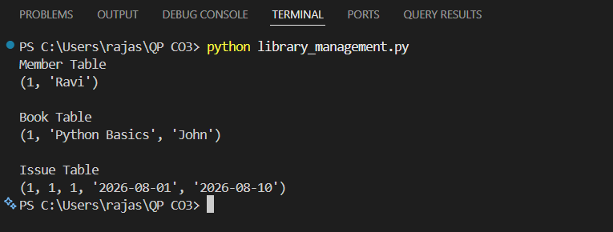

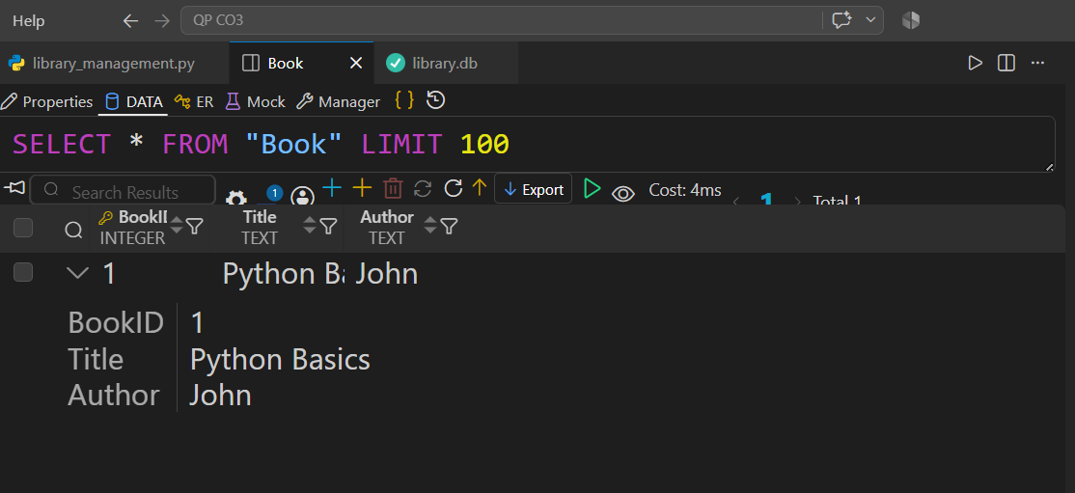
Viva Q&A
Q1. Explain the relationship between Member and Book through the Issue table.
Answer:
The Issue table connects the Member and Book tables. One member can borrow many books, and one book can be borrowed by different members at different times. Hence, it represents a many-to-many relationship.

Q2. How would you modify the schema to track overdue fines?
Answer:
Add a FineAmount column to the Issue table or create a separate Fine table containing FineID, MemberID, BookID, FineAmount, and PaymentStatus.

9. Learning Management System (LMS)
Tables:
- Student(StudentID, Name)
- Course(CourseID, CourseName)
- Enrollment(StudentID, CourseID)
- Assignment(AssignmentID, CourseID)
Students can enroll in many courses.

Viva Questions
Q1. Why is Enrollment considered a bridge table?
Q2. How would you modify the schema to record assignment grades?

Aim:
To create a Learning Management System using PostgreSQL and Python and perform CRUD (Create, Read, Update, Delete) operations on the Student, Course, Enrollment, and Assignment tables.

Program:
import psycopg2

# Connect to PostgreSQL
conn = psycopg2.connect(
host="localhost",
database="lms_db",
user="postgres",
password="your_password"
)

cursor = conn.cursor()

# Create Student table
cursor.execute("""
CREATE TABLE IF NOT EXISTS Student(
StudentID SERIAL PRIMARY KEY,
Name VARCHAR(50)
)
""")

# Create Course table
cursor.execute("""
CREATE TABLE IF NOT EXISTS Course(
CourseID SERIAL PRIMARY KEY,
CourseName VARCHAR(50)
)
""")

# Create Enrollment table
cursor.execute("""
CREATE TABLE IF NOT EXISTS Enrollment(
StudentID INT,
CourseID INT,
FOREIGN KEY(StudentID) REFERENCES Student(StudentID),
FOREIGN KEY(CourseID) REFERENCES Course(CourseID)
)
""")

# Create Assignment table
cursor.execute("""
CREATE TABLE IF NOT EXISTS Assignment(
AssignmentID SERIAL PRIMARY KEY,
CourseID INT,
FOREIGN KEY(CourseID) REFERENCES Course(CourseID)
)
""")

# Insert records
cursor.execute("INSERT INTO Student(Name) VALUES('Rahul')")
cursor.execute("INSERT INTO Course(CourseName) VALUES('Python Programming')")
cursor.execute("INSERT INTO Enrollment(StudentID, CourseID) VALUES(1,1)")
cursor.execute("INSERT INTO Assignment(CourseID) VALUES(1)")

conn.commit()

# Display Student table
print("Student Table")
cursor.execute("SELECT * FROM Student")
for row in cursor.fetchall():
print(row)

# Display Course table
print("\nCourse Table")
cursor.execute("SELECT * FROM Course")
for row in cursor.fetchall():
print(row)

# Display Enrollment table
print("\nEnrollment Table")
cursor.execute("SELECT * FROM Enrollment")
for row in cursor.fetchall():
print(row)

# Display Assignment table
print("\nAssignment Table")
cursor.execute("SELECT * FROM Assignment")
for row in cursor.fetchall():
print(row)

cursor.close()
conn.close()
Output:
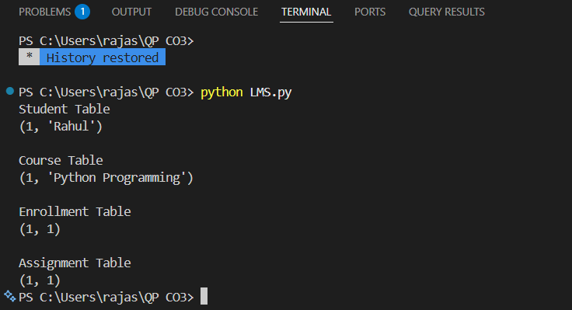

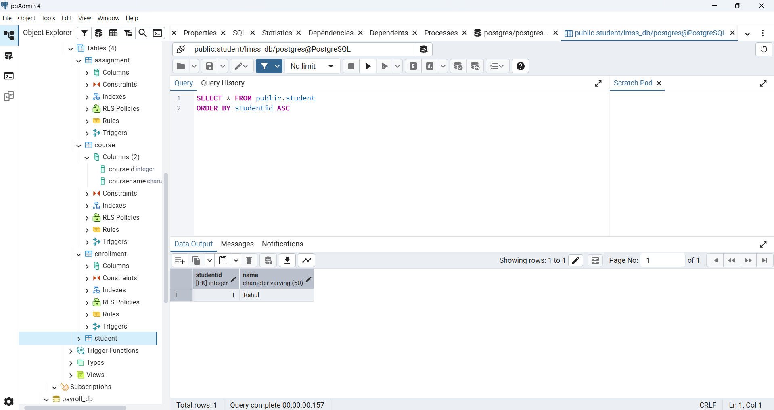

Viva Q&A:
Q1. Why is Enrollment considered a bridge table?
Answer:
Enrollment is a bridge table because it connects Student and Course. It allows one student to enroll in many courses and one course to have many students.

Q2. How would you modify the schema to record assignment grades?
Answer:
Add a Grade column to the Assignment table or create a separate Submission table with StudentID, AssignmentID, Grade, Marks, and SubmissionDate.

